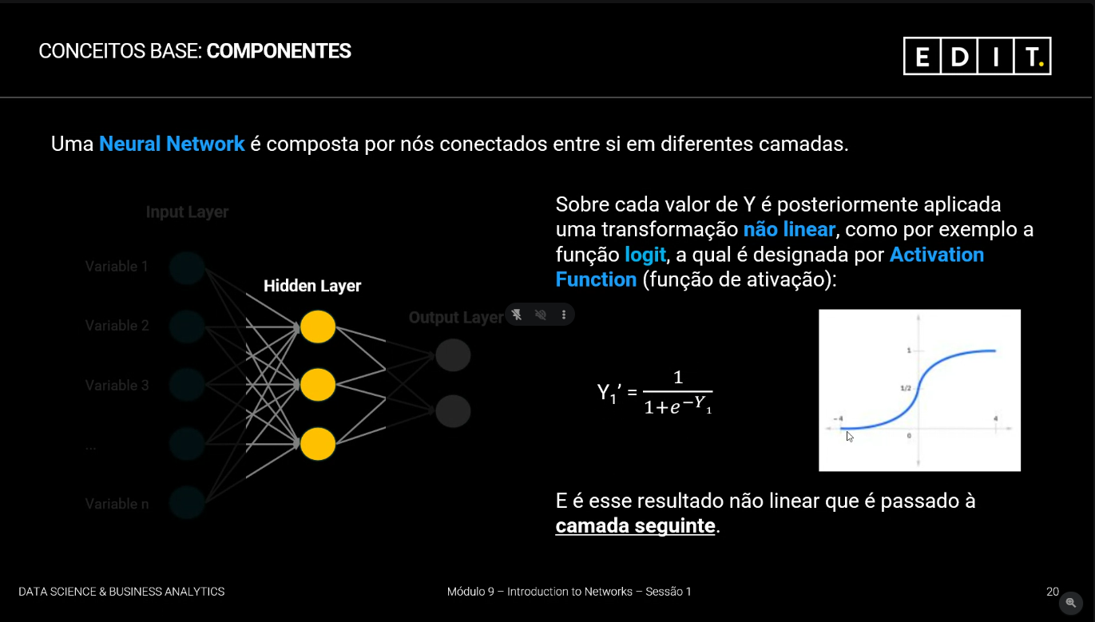

Rede neuronal sem hidden layer

a-> é um bias

A rede neuronal começa com parâmetros aleatórios e depois é que começa a aprender a ajustar.

Como vamos partir os dados? Que cuidados vamos ter?

Hora de transação – é mesmo hora

